填表说明

此样式为毕业证书和学位证书英文翻译认证样式；

证书为本人毕业证和学位证原件的复印或扫描（可缩印）；

英文翻译可参考学校的文本（证明中文本红色加粗部分文字为证件持有人的实际信息，请如实填写，打印时用黑色打印）或对照证书原件如实翻译。

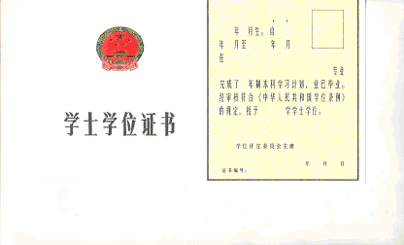
Certificate for Bachelor’s Degree

This is to certify that Ms. Shi Jue, born in May 1982, having specialized in Agronomy at the College of Agronomy, Northwest A&F University from September 2000 to July 2004, has qualified for graduation. Upon the examination and in conformity with the articles of the Regulations Regarding Academic Degrees in the People’s Republic of China, she has been admitted to the Bachelor’s Degree of Agriculture.

Sun Qixin
Chairman of Academic Degrees
Northwest A&F University
July 1, 2004
Certificate No. 1071242004000000

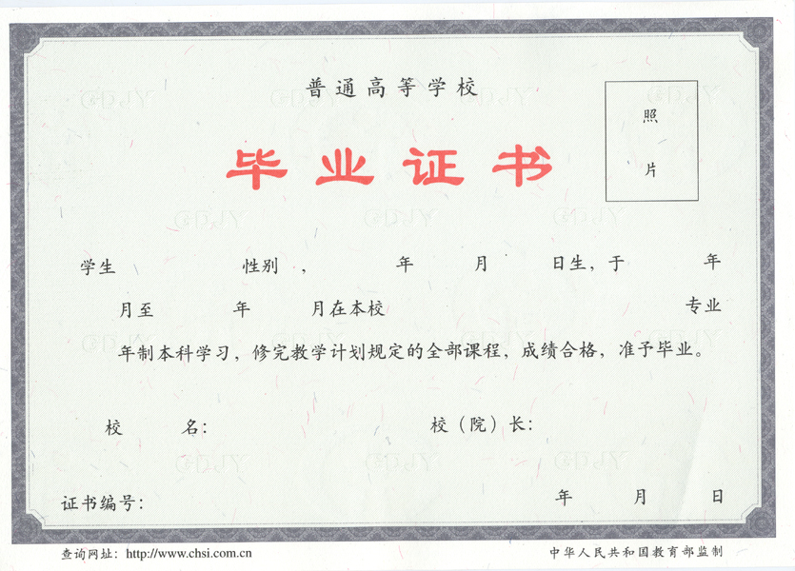
Certificate of Graduation

This is to certify that Ms. Shi Jue, born on May 29, 1982, having specialized in Agronomy at the College of Agronomy, Northwest A&F University from September 2000 to July 2004 and having completed the four-year undergraduate program with qualified standard, is hereby awarded this Certificate of Graduation.

Sun Qixin
President
Northwest A&F University
July 1, 2004
Certificate No. 107121200400000000

